RESOLUTION NO.__________

RE: CERTIFICATE OF APPROPRIATENESS UNDER THE
PROVISIONS OF THE ACT OF THE PENNSYLVANIA
LEGISLATURE 1961, JUNE 13, P.L. 282 (53
SECTION 8004) AND BETHLEHEM ORDINANCE NO.
3952 AS AMENDED.

WHEREAS, it is proposed to install a sign above the entrance door and two vinyl window signs at 523 Main St. (formerly In The Mood)

NOW, THEREFORE, BE IT RESOLVED by the Council of the City of Bethlehem that a Certificate of Appropriateness is hereby granted for the proposal.

Sponsored by: (s)

(s)

ADOPTED BY COUNCIL THIS DAY OF

(s)
President of Council

ATTEST:

(s)
City Clerk

HISTORICAL & ARCHITECTURAL REVIEW BOARD

The applicant proposes to install a sign above the entrance door and two vinyl window signs at 523 Main St. (formerly In The Mood)
APPLICATION #2:

Barry Pell
525 Main St.
Bethlehem, PA 18018

OWNER:

__________________________________________________________________________

The Board upon motion by Marsha Fritz and seconded by Beth Starbuck adopted the proposal that City Council issue a Certificate of Appropriateness for the following:

- Install a wall sign with black background with white letters and pinstripe outline.

2. Vinyl logos placed on the windows with “off white” letters and vinyl background.

3. The motion was unanimously approved.

__________________________________________________________________________

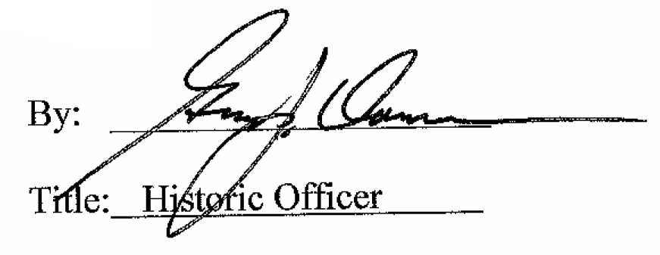

Date of Meeting: June 1, 2016

